|  |  |  |  |
| --- | --- | --- | --- |
| **Name of Student: NINAD AVINASH PATIL** | | | |
| **Roll No: 33** | | **Lab Practical Number: 2.2** | |
| **Title of Lab Practical: Design a bank account class with different operations such as Deposit, Withdraw etc. Also define MINBAL Exception if the balance goes less than 100.Demonstrate using appropriate GUI.** | | | |
| **DOP: 03/03/2021** | | **DOS: 10/03/2021** | |
| **CO Mapped: CO1** | **PO Mapped: PO3, PO5, PO7,**  **PO12, PSO1, PSO2** | **Faculty Signature:** | **Marks:** |

**Practical No 2.2**

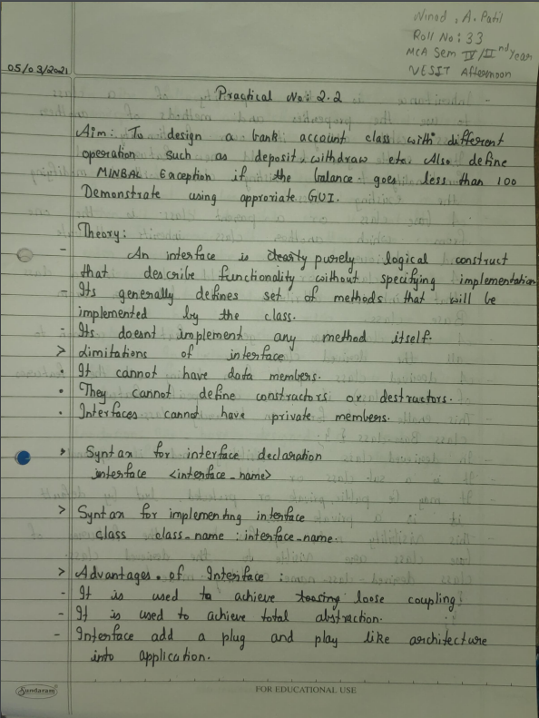

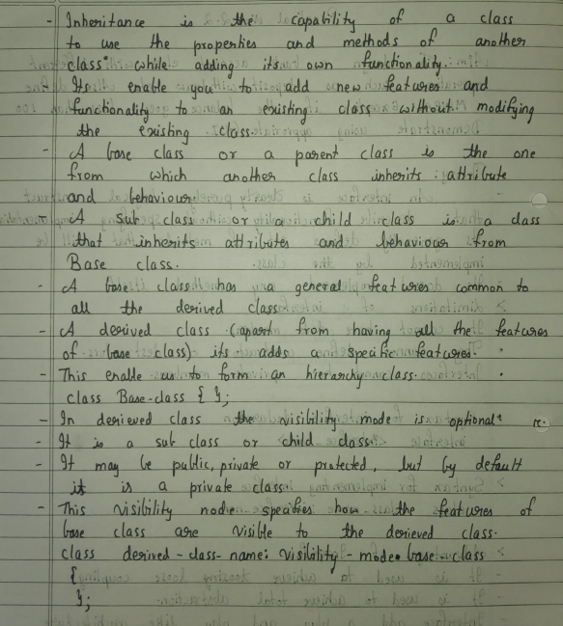

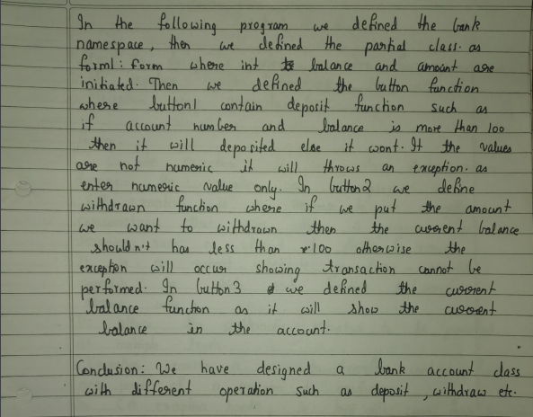

**Code:**

using System;

using System.Collections.Generic;

using System.ComponentModel;

using System.Data;

using System.Drawing;

using System.Linq;

using System.Text;

using System.Windows.Forms;

namespace Bank

{

public partial class Form1 : Form

{

int balance = 0;

int a;

public Form1()

{

InitializeComponent();

label3.Visible = false;

label4.Visible = false;

}

private void textBox1_TextChanged(object sender, EventArgs e)

{

}

private void button1_Click(object sender, EventArgs e)

{

label3.Visible = false;

label4.Visible = false;

try

{

a = Convert.ToInt32(textBox2.Text);

if (textBox1.Text == "8097230640" && a >= 100)

{

balance = balance + a;

label4.Text = Convert.ToString(balance);

MessageBox.Show("Successfully deposited amount into the bank");

}

else

{

MessageBox.Show("Wrong A/C No entered or amount is less than 100");

}

}

catch(Exception)

{

MessageBox.Show("Please enter numeric values only");

}

}

private void button2_Click(object sender, EventArgs e)

{

label3.Visible = false;

label4.Visible = false;

try

{

try

{

a = Convert.ToInt32(textBox2.Text);

}

catch (Exception) { MessageBox.Show("Please enter numeric values"); }

if (textBox1.Text == "8097230640" && a%100==0)

{

if((balance-a)<100)

{

throw (new MINBALException("Current balance will be less than 100. \nHence transaction cannot be performed."));

}

else

{

balance = balance - a;

label4.Text = Convert.ToString(balance);

MessageBox.Show("Successfully withdrawn from banks");

}

}

else

{

MessageBox.Show("Wrong A/C No entered or amount is not a multiple of 100");

}

}

catch (MINBALException ex)

{

MessageBox.Show(ex.Message);

}

}

private void button3_Click(object sender, EventArgs e)

{

try

{

long x = Convert.ToInt64(textBox1.Text);

if (x == 8097230640)

{

label3.Visible = true;

label4.Visible = true;

}

else {

label3.Visible = false;

label4.Visible = false;

MessageBox.Show("Entered account does not exist");

}

}

catch (Exception)

{

label3.Visible = false;

label4.Visible = false;

MessageBox.Show("Please enter numeric values");

}

}

}

}

public class MINBALException : Exception

{

public MINBALException(string message)

: base(message)

{

}

}

**Output:**

